Internet and Network Vocabulary

1. **Wide Area Network** - It stands for Wide Area Network and covers a wide area such as a city.

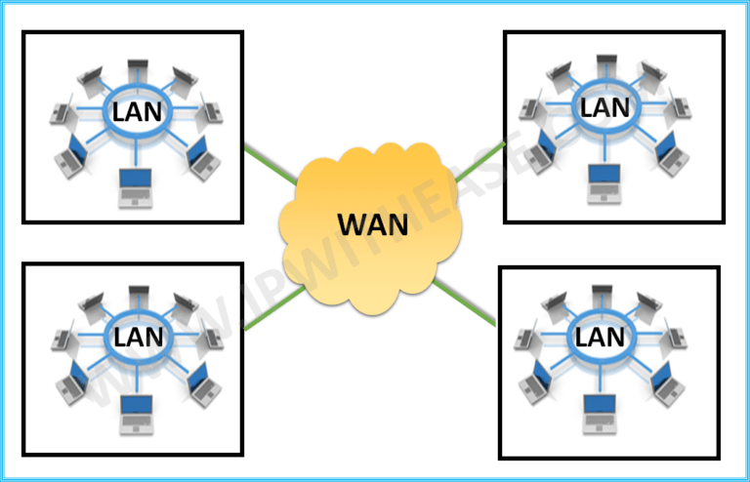

2. **Host** – A device connected to a network. Those are host in the figure above.

3. **End systems** - a computer connected to a computer network is sometimes referred to as an end system

4. **Bandwidth** - loosely used to refer to the information-carrying capacity of a network or component of a network.

5. **Bit rate** - The rate at which bits are transmitted or received during communication, expressed as the number of bits in each amount of time, usually one second.

16. **Route** - A route defines a path for sending packets through the Internet network to an address on another network.

17. **Path -** Path Networks consist of nodes and path segments that connect nodes to other nodes.

18. **Hosts -** A network host is a computer or other device connected to a computer network.

19. **Edge router** - An edge router is a specialized router located at a network boundary that enables an internal network to connect to external networks.

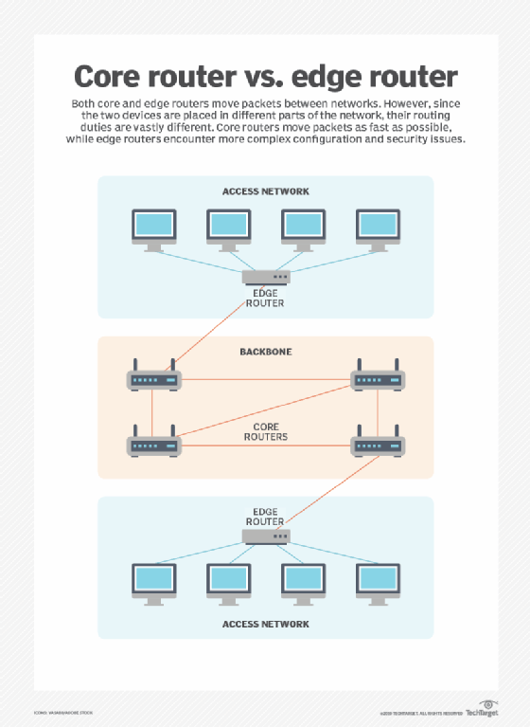

20. **Clients -** a client is any computer hardware or software device that requests access to a service provided by a server.

21. **Servers** - A server is a computer or system that provides resources, data, services, or programs to other computers, known as clients, over a network.

22. **Digital subscriber Line** - Digital subscriber line is a family of technologies that are used to transmit digital data over telephone lines.

23. **Internet Service Providers** - An ISP, or internet service provider, is a company that lets you access the internet from home, usually with a monthly subscription.

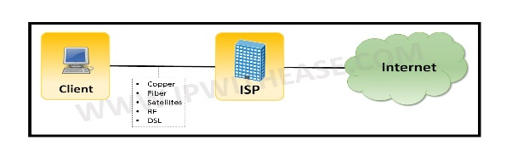

24. **Protocols** - A network protocol is an established set of rules that determine how data is transmitted between different devices in the same network.

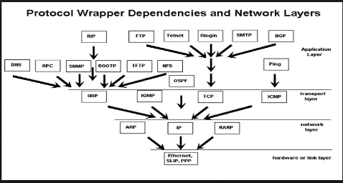

25. **Wireless network** - A wireless network refers to a computer network that makes use of Radio Frequency (RF) connections between nodes in the network.

41. **SMTP** - SMTP (Simple Mail Transfer Protocol) is a TCP/IP protocol used in sending and receiving e-mail.

42. **Local Area Network** - A local area network (LAN) is a collection of devices connected in one physical location, such as a building, office, or home.

43. **Distributed applications** - A distributed application is a program that runs on more than one computer and communicates through a network.

44. **Application Programming Interface** - An application programming interface (API) is a connection between computers or between computer programs.